Business Question and Visualization Report 

Date | 21 September 2026
Team ID | MCA
Project Name | Strategic Employee Attrition Intelligence Board
Maximum Marks | 5 Marks

Visualization development refers to the process of creating graphical representations of data to facilitate understanding, analysis, and decision-making. The goal is to transform complex datasets into visual formats that are easy to interpret, enabling users to gain insights and make informed decisions. Visualization development involves selecting appropriate visual elements, designing layouts, and using interactive features to enhance the user experience. This process is commonly associated with data visualization tools and platforms, and it plays a crucial role in business intelligence, analytics, and reporting
Business Questions and Visualisation
The process involves defining specific business questions to guide the creation of meaningful and actionable visualizations in Power BI. Well-framed questions help in identifying key metrics, selecting relevant data, and building visualisation that provide insights.

1.How does employee attrition count vary across different departments?
Visualization: Clustered Bar Chart

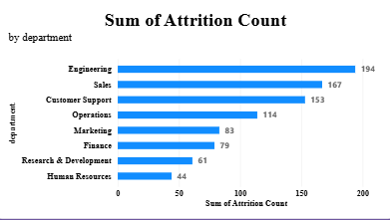

2.Which job roles have higher or lower employee attrition rates?
Visualization: Clustered Bar Chart
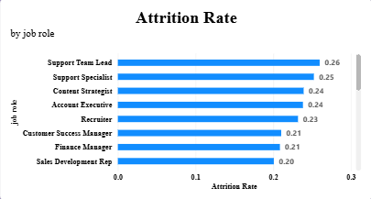

3.How is the employee population distributed across different work modes?
Visualization: Clustered Bar Chart

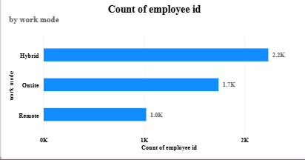

4.How does employee attrition count differ across Remote, Hybrid and Onsite work modes?
Visualization: Clustered Bar Chart

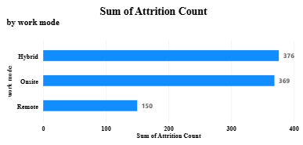

5.How are employees distributed across different job levels?
Visualization: Donut Chart

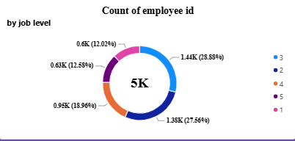

6.How does the average job level vary according to attrition status and marital status?
Visualization: Clustered Bar Chart

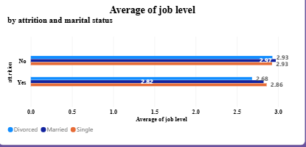

7.How does average monthly income vary across different marital-status groups?
Visualization: Clustered Column Chart

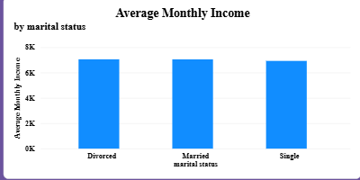

8.How does the attrition rate change across different career stages or age groups?
Visualization: Line Chart

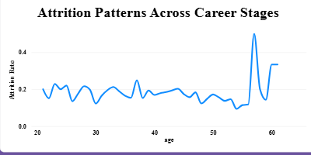

9.How does attrition rate vary across work modes and different burnout-risk levels?
Visualization: Clustered Bar Chart

